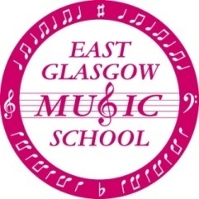
Re-Registration for 2018-2019

Dear Parent/Guardian,

Thank you for your support over the past year. In order to help with planning for next session and to ensure that all our existing pupils can continue with their lessons without interruption I would ask that you complete the attached re-registration form.

Those choosing to continue with their current instrument will automatically be timetabled next session. Children requesting a change of instrument will be contacted after the summer and asked to attend one of the open days in September to try out their chosen instrument. Details of the open days will also be on our website.

Those children who are finishing Primary 7 will no longer be able to receive an instrumental lesson at the Music School but are most welcome to return and play in the Orchestra/Recorder Group and sing with the choir and/or vocal ensemble. Please come along at the usual times on Saturday 29th September 2018.

Please return the form to Gillian Currie or your instrumental tutor by Saturday 28th April 2018.

----------------------------------------------------------------------------------------------cut here----------------------------------------
Please complete clearly using BLUE or BLACK INK and BLOCK CAPITALS
I wish to re-register my child for tuition at East Glasgow Music School for the session 2018/2019

Name of Child:
Date of Birth: |  | Telephone No:
Address:

Postcode:
School Attended Next Year:
Year in School 2016/2017:  (please circle) | Primary  1 2 3 4 5 6 7 |  | Secondary  1 2 3 4 5 6
Email address:
Name of Parent or Carer:
Signature of Parent or Carer:
Instrument Played (if already receiving tuition)
Name of Instrumental Teacher
Instrument Requested (only if changing instruments) | 1st Choice |  |  | 2nd Choice

